John Stahl named London Strawberry Festival Grand Marshall

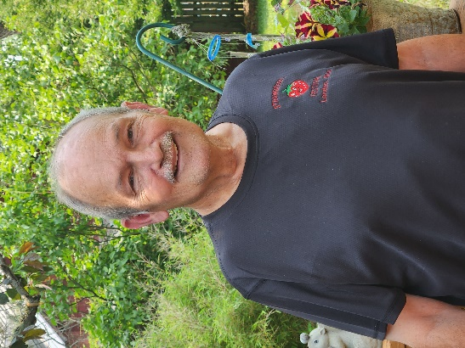
It is great with great pleasure that we announce John Stahl as the 2023 Grand Marshall of the London Strawberry Festival Parade.
John is a lifelong London resident and graduate of the London High School class of 1966.
His high school career was well spent as an active member of FFA where he enjoyed participating in the public speaking team, as well as soil and animal judging teams. He went on to graduate with his Bachelor of Business from Franklin University. He has recently celebrated 21 years with Ohio Processors!
John, and his wife of almost 48years, Jan, felt that there was no better place to call home than London. They have been blessed with three children and have since welcomed 8 grandchildren and 2 great-grandchildren If you can't find John at home with his family and pets, then you are sure to find him enjoying his time gardening and caring for their numerous animals, traveling far and wide to all of Ohio's Fairs and Festivals, or with one of the numerous organizations he remains active in.

Throughout his life he has had numerous accomplishments and continues to do so. His passion for trees and gardening led to founding the local Tree Commission in 1986. This has allowed London to hold the title of a National Tree City with the Arbor Day Foundation for 36 years! He also proudly helped create the city motto m 1979 which remains today as “London­ A Proud Heritage, A Promising Future." His love for fairs and festivals didn't start from just anywhere. He served as a 4-H advisor for 25years with Jolly Green Growers where the club focused on growing vegetables and flowers. He later stepped into the roles of Senior Fair Board member where he worked directly with vendors and the Grange Hall and served as the President of the 4-H advisory committee. John has also been a city council member for most of the last 25 years even having spent a period as the president pro tem. He continues to strive to make impactful changes to the City of London and is currently working to start a TNR program to help with the stray cat population.

John got his start with the London Strawberry Festival when it was still known as the London Mangold Festival During his first year as a city council member he volunteered to assist with the festival and has been an active member ever since. His love for the festival doesn't stop with him. His daughter, Jaimee, was the 1994 Mangold Queen and his granddaughter, Elizabeth was the 2009 Jr Miss Strawberry. John was an integral part of helping the festival become a member of the Ohio Festival and Events Association. He is currently serving as the London Strawberry Festival President and works directly with the vendor and entertainment committees. He loves everything about the festival except for the clean-up!

