Charms | Item Description |  | Item Number | Selling Price | Available
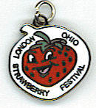 | LSF Charm  Strawberry Shaped |  | SBC-1 | 5.00
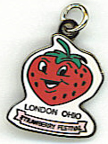 | LSF Charm  Strawberry Shaped with Pink Banner |  | SBC-2 | 5.00 | 7 3/21/2020
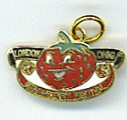 | LSF Strawberry Charm with Banner |  | SBC-3 | $5 | 244 3/21/2020
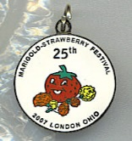 | 25th Anniversary Charm |  | SBC-4 | 5.00 | 7 3/21/2020
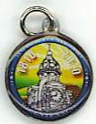 | MC Bicentennial |  | MCB-C | 5.00 | 63 3/21/2020
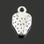 | Strawberry Silvertone charm |  | Str-s | $2.00 | 21 3/25/2020
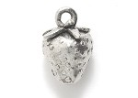 | Strawberry Silver 10x15mm |  | PW4187-S | 5.00 | 1 3/21/2020
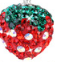 | Rhinestone (red, green & clear) strawberry (no chain) (can be used as charm or pendant) |  | RhSB-Rcl | $5.00 | 7 3/21/2020
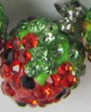 | Rhinestone (red, green & black) strawberry |  | RhSB-Rbl | $5.00
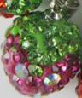 | Rhinestone (purple, green & clear) strawberry |  | RhSB-P | $5.00 | 3 3/21/2020
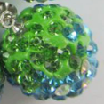 | Rhinestone (blue, green & clear) strawberry |  | RhSB-B | $5.00 | 3 3/21/2020
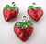 | Red Enamel Strawberry Charms |  | SB-en | $5.00 | 7 3/21/2020
 | Red Enamel Strawberry Charms about ½” |  | SB-cast | $5.00 | 3 3/21/2020
 | Red Enamel Strawberry Charms  gold tone back |  | SB-G | $5.00 | 29 3/21/2020
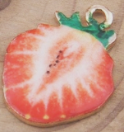 | Sliced Strawberry charms |  | slice | $3.00 | 38 3/21/2020
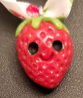 | handmade strawberry charms |  | hand | $5.00
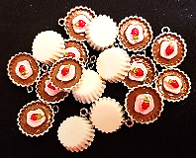 | Cupcake charms  white paper choc/pink |  | 98562638 | 2.00 | 17 3/21/2020
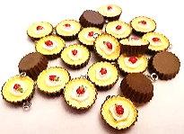 | Cupcake charms  brown paper yellow/white |  | 98562638 | 2.00 | 21 3/21/2020
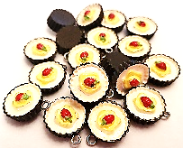 | Cupcake charms  brown paper white/yellow |  | 98562638 | 2.00 | 19 3/21/2020
 | Cupcake charms  pink paper white/choc |  | 98562638 | 2.00 | 21 3/21/2020
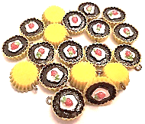 | Cupcake charms  yellow paper choc/white |  | 98562638 | 2.00 | 19 3/21/2020
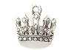 | silver tiara-points charm |  | TCP | $3.00 | 10 3/21/2020
 | silver tone tiara-loops charm |  | TCL | $3.00 | 55 3/21/2020
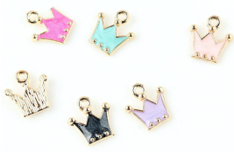 | enameled crown |  | SM EN T | $3.00 | 10 white 3/21/2020  10 lt pink  10 pink  10 lavender  10 blue  10 black
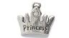 | Princess Crown With Crystal Bright Silver 11x15 |  | PW1101-AS | $3.00 | 16 3/21/2020
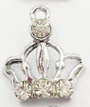 | Silver tone tiara charm with 3 rhinestones @ bottom band & 1 in top point |  | T-Rh | $5.00 | 31 3/21/2020
 | Silver tone tiara charm with rhinestone in each of the 5 points |  | T-FRH | $3.00 | 4 3/21/2020
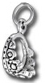 | silver tiara charm |  | 3dt | $5.00 | 1 3/21/2020
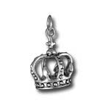 | silver crown charm |  | 3dcrown | $10.00 | 9 3/21/2020
 | antiqued rhinestone crown charm/pendant |  | Ant Cr | $6.00 | 2 3/21/2020
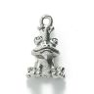 | silver,  Frog Prince With Crown Silver 18mm |  | PW5129-S | $4.00 | 10 3/21/2020
 | Frog Prince With Crown |  | fr-Pr | 3.00 | 2 3/21/2020
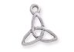 | Silver Triquetra |  | PW922-S | 3.00 | 2 3/21/2020
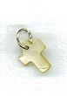 | Cross |  | coss | 2.00 | 5 3/21/2020
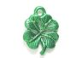 | Green 4 leaf clovers |  | PW3383-G | 4.00 | 5 3/21/2020
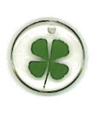 | Real 4-leaf clover in acrylic |  | acclover | 5.00 | 4 3/21/2020
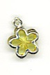 | flower–multi color  plastic |  | pl-fl | 25¢ | 4 gold 3/21/2020  4 green  5 blue  2 red  10 lavender  15 yellow
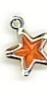 | Stars–multi color  plastic |  | pl-st | 25¢ | 7 red 3/21/2020  4 clear  1 lime  2 aqua  4 royal  6 pink  7 lavender
 | Starfish  gold tone plastic |  | pl-sf | 50¢ | 4 3/21/2020
 | Boat steering wheel  gold tone plastic |  | wheel | 50¢ | 2 3/21/2020
 | Star/USA Silver 11x16mm |  | PW9880-S | 3.00 | 2 3/21/2020
 | Crescent Moon  Antiqued silver tone |  | moon | 3.00 | 2 3/25/2020
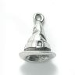 | Witches hat |  | PW166-S | 5.00 | 9 3/21/2020
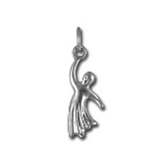 | Ghost charm-Sterling silver |  | ghost | 6.00 | 3 3/21/2020
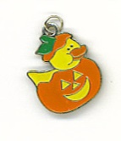 | Pumpkin & duck charm |  | p-du | 5.00 | 19 3/21/2020
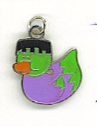 | Frankenstein rubber Duck |  | fr-du | 5.00 | 12 3/21/2020
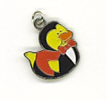 | Vampire rubber Duck |  | va-du | 5.00 | 19 3/21/2020
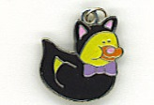 | Cat rubber duck |  | c-du | 5.00 | 20 3/21/2020
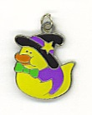 | Witch rubber duck |  | w-du | 5.00 | 18 3/21/2020
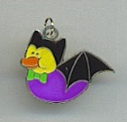 | Bat Rubber Duck |  | bat | 5.00 | 17 3/21/2020
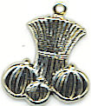 | Corn stalks & Pumpkins-flat |  | har | 2.00 | 10 3/21/2020
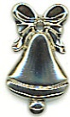 | Flat Christmas Bells |  | bell | 2.00 | 17 3/21/2020
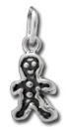 | Tiny Gingerbread Man  Height: 12mm  Weight: 0.60g |  | gin | 5.00 | 2 3/21/2020
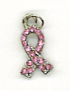 | Breast Cancer Awareness Ribbon |  | cancer | 1.00 | 11 3/21/2020
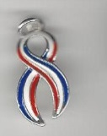 | Patriotic Awareness Charm |  | pat-aw | $5.00 | 46 3/21/2020
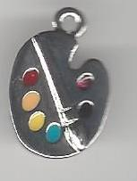 | Artist Pallet silver tone |  | art | $2.00 | 7 3/21/2020
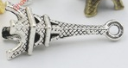 | Eiffel Tower charm  silver tone |  | tower | $2.00 | 1 3/21/2020
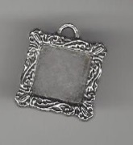 | frame silver tone |  | frame | $2.00 | 1 3/21/2020
 | heart nurse |  | nurse | $2.00 | 1 3/21/2020
 | sun & stars |  | s-s | $2.00 | 1 3/21/2020
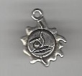 | sun charm |  | sun | $2.00 | 1 3/21/2020
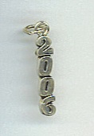 | 2006 Vertical Sterling Silver charm |  | 06v | $1.00 | 2 3/21/2020
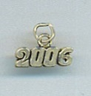 | 2006Horizontal Sterling Silver charm |  | 06h | $1.00 | 3 3/21/2020
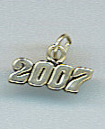 | 2007 Charm |  | 07h | $1.00 | 1 3/21/2020
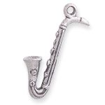 | Sax |  | sax | $3.00 | 5 3/21/2020
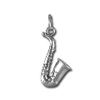 | Sterling Silver Sax |  | s-sax | $9.00 | 1 3/21/2020
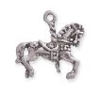 | Carousel Horse Charm Silver 23x24mm |  | PW414-S | $4.00 | 5 3/21/2020
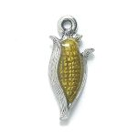 | Corn With Epoxy Antique Silver 9x21mm |  | PW9274-ES | $5.00 | 4 3/21/2020
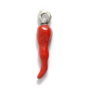 | Red enamel Chili pepper charm |  | pep | $5.00 | 1 3/21/2020
 | antiqued daisy with pearls charm/pendant |  | daisy | $6.00 | 2 3/21/2020
 | Silver plated farmer/tractor charm |  | trac | $3.00 | 17 3/21/2020
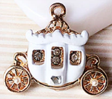 | small white enamel carriage charm with rhinestones |  | sm-w-car | $8 | 19 3/21/2020
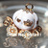 | white enamel carriage charm |  | 3dcar-w | $10 | 4 3/21/2020
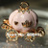 | pink enamel carriage charm |  | 3dcar-p | $10
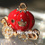 | red enamel carriage charm |  | 3dcar-r | $10 | 3 3/21/2020
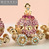 | Pink Rhinestone carriage charm |  | 3dcar-rh | $12 | 14 3/21/2020
Floating Charms & Locket | Item Description |  | Item Number | Selling Price | Available
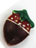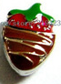 | double sided chocolate strawberry floating charm |  | ch-sb-f | $1.00 | 60 3/21/2020
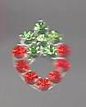 | red rhinestone strawberry floating charms |  | rh-sb-f | $1.00 | 21 3/21/2020
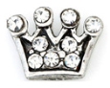 | clear rhinestone floating charm crown |  | tiara-f | $1.00 | 18 3/21/2020
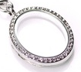 | silver tone locket with rhinestones on serpentine chain |  | locket | $10 | 6 3/21/2020
Bracelets |  | Item Description | Item Number | Selling Price | Starting Inventory
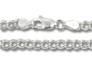 |  | Sterling Silver Charm Bracelet  7”  8” | 080 | 22.00  24.00 | 1 3/21/2020  0 3/21/2020
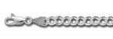 |  | Charm Link 070, Sterling Silver  7"  8" | 070 | 21.00  24.00 | 3 3/21/2020  7 3/21/2020
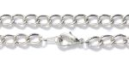 |  | Chain Bracelet With Clasp 7.5in  Silver tone | FI950-S | 5.00
 |  | 4 strand charm bracelet  6.5” silver tone  (3 strands chain + 1 strand rhinestone) | multi-strand | $12.00 | 3 3/21/2020
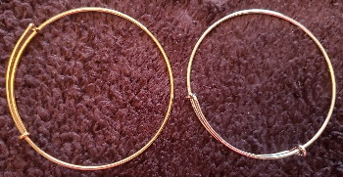 |  | Bangle style charm bracelet |  | $5 | Silver 4 3/21/2020  Gold 1  Bronze 2

