MISC. ITEMS | Item Description | Item Number | Selling Price | Available
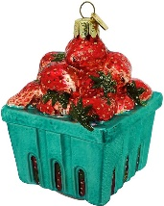 | Strawberry Basket Ornament |  | $15 | 5 3/21/2020
 | Chocolate Covered Strawberry Ornament |  | $15 | 7 3/21/2020
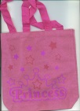 | Princess Bag  8’x8” |  | $2.00 | 6 3/21/2020
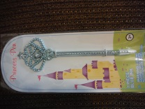 | Princess Pen |  | $1.50
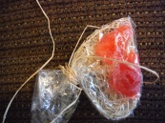 | Strawberry Soap |  | .50 | 7 3/21/2020
 | beeswax strawberry ornament  aprox 1” |  | .50 | 30 3/21/2020
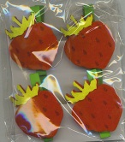 | 4 pieces felt strawberry clips |  | $2.00 | 6 3/21/2020
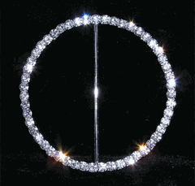 | Rhinestone Belt Buckle  3” diameter |  | $4.50 | 11 3/21/2020
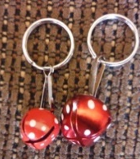 | Strawberry Jingle Bell Key Chain |  | .50 | 13 3/21/2020
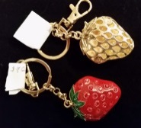 | Enamel Red Stone Strawberry Key Chain |  | $7 | 2 3/21/2020
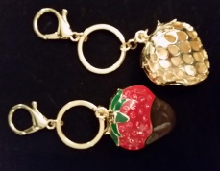 | Enamel Red Stone Chocolate Dipped Strawberry Key Chain |  | $7 | 7 3/21/2020
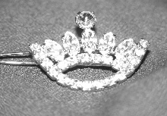 | Crown barrette |  | 7.50
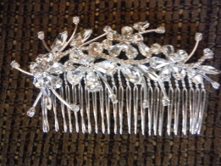 | Rhinestone Comb |  | $25
 | Infant or doll crown |  | $5
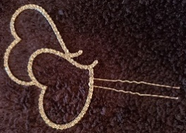 | Hair pin with double rhinestone hearts |  | $5 | 1 3/21/2020
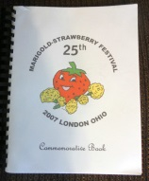 | 25th Anniversary Cook Book |  | $5 | 3 3/21/2020
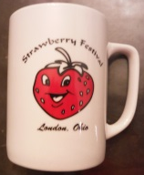 | London Strawberry Festival Mug |  | $3.00 | 2 3/25/2020
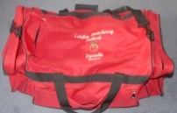 | large red duffel with black trim; name & title embroidered on it. |  | $35 | 2 3/25/2020
Scrap Book Items | Item Description | Item Number | Selling Price
2014 | 2014 Queens luncheon photo 4x10 panoramic |  | $2.00 | 13 3/21/2010
2017 | 2017 Queens luncheon photo 4x10 panoramic |  | $2.00 | 5 3/21/2010
2018 | 2018 Queens luncheon photo 4x10 panoramic |  | $3.00 | 19 3/21/2010
2019 | 2019 Queens luncheon photo 4x8 panoramic |  | $5.00 | 3 3/21/2010
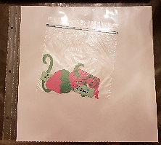 | white scrapbook page kit –contains plastic protector, white page, strawberry, vine, crown or festival name |  | $5 | 8 3/25/2020
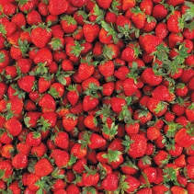 | strawberry scrapbook page |  | $1 | 32 3/25/2020
 | London Strawberry Festival Logo die cut (3 pieces)  approx. 3” wide x 4” tall |  | $3 | 8 3/25/2020
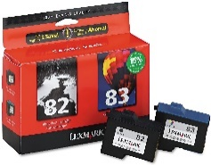 | Lexmark ink cartridges  #82 Black, #83 color |  | $7  $5 | 5 color  4 black  3/21/2020
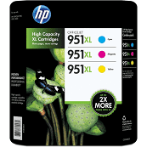 | HP Magenta & Cyan |  | $10 | 1 ea. 3/21/2020
Clothes | Item Description | Item Number | Selling Price
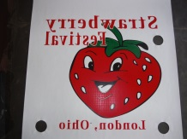 | Festival T-Shirt Screens  (screen pic shows in reverse but transfers correctly) |  | $15 on t shirt | 14 3/25/2020
 | Rhinestone Tiara Transfer  approx. 2 ½” wide x 4” tall |  | $10 on t shirt | 30 3/25/2020
 | Rhinestone Strawberry Logo Transfer  approx. 3 ½” wide x 3 ½” tall |  | $12 on t shirt | 18 3/25/2020
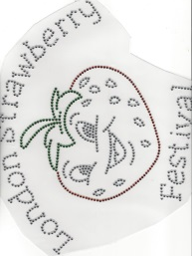 | Rhinestone LSF Logo Transfer  approx. 11 ¼” wide x 9” tall |  | $18 on t shirt | 11 3/25/2020
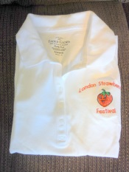 | London Strawberry Festival  embroidered polo  child’s size 4-6 |  | $10 | 1 3/21/2020
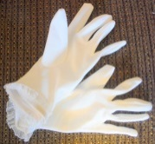 | kids white dress gloves |  | $2 | 3 3/21/2020
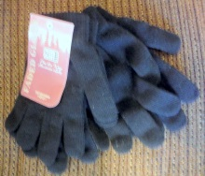 | black knit gloves |  | $1
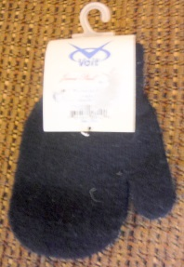 | Child’s black mittens |  | $1 | 1 3/21/2020
Necklaces | Item Description | Item Number | Selling Price
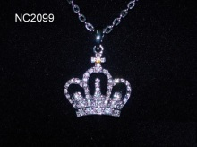 | clear necklace | NC2099 | 8.00
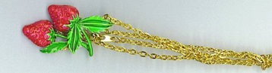 | Dble Strawberry necklace with gold tone chain |  | 7.00
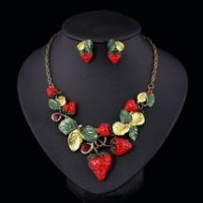 | Strawberry post earrings & necklace set |  | $20.00 | 1 3/21/2020
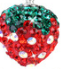 | Rhinestone (red, green & clear) strawberry on silver serpentine chain |  | $10
 | Patriotic heart with rhinestones  pendant charm on silver chain  1 3/8” wide x 1” tall |  | $5.00 | 5 3/21/2020
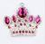 | Silver tone clear & pink rhinestone  pendant charm on silver chain  1 ¾” wide x 1 ½” tall |  | $5.00 | 4 3/21/2020
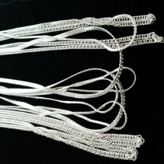 | silver tone 18” chain | ch-s18 | $2.00 | 13 3/21/2020
 | silver tone 24” chain | ch-s24 | $3.00 | 10 3/21/2020
 | gold tone 24” chain | ch-g24 |  | 12 3/21/2020
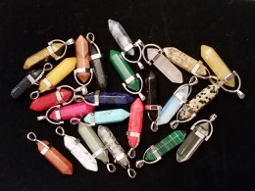 | gemstone points varied stones |  | $5. 00 stone only  $8.00 with chain | 22 3/21/2020
Earrings | Item Description | Item Number | Selling Price
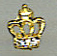 | Tiny gold crown post earrings |  | 3.00 | 12 3/21/2020
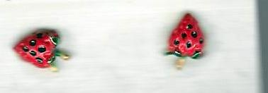 | Small Strawberry post earrings |  | $5.00
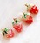 | small strawberry post earrings |  | $3.00 | 4 3/21/2020
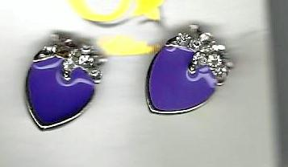 | Enamel Strawberry post earrings |  | $4.00 | 3/21/2020  2 black  1 purple  1 pink
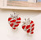 | enamel & rhinestone post earrings |  | $4.00
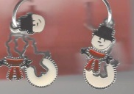 | snowman with hat charm hoop earrings |  | $3.00  Can’t restock | 2 3/21/2020
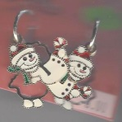 | snowman with candy cane charm hoop earrings |  | $3.00  Can’t restock | 1 3/21/2020
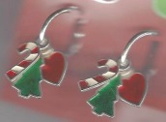 | candy cane, tree, heart charm hoop earrings |  | $3.00  Can’t restock | 3 3/21/2020
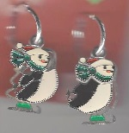 | penguin on skates charm hoop earrings |  | $3.00  Can’t restock | 5 3/21/2020
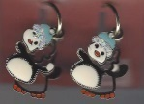 | penguin with blue hat charm hoop earrings |  | $3.00  Can’t restock | 2 3/21/2020

