 | Item Description | Item Number | Selling Price | Available
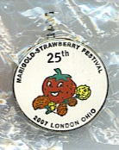 | 25th Anniversary Tac Pin | SC-tac | 3.00 | 58 3/21/2020
 | MC Bicentennial Tac Pin | Bic-tac | 5.00 | 1 3/21/2020
 | Lg Strawberry Rhinestone Pin  1 ½” wide x 2” tall | lg RH sb | $12 | 33 3/21/2020
 | Sm Strawberry Rhinestone Pin  3/4” wide x 1 1/8” tall | sm rh sb | $5 | 9 3/21/2020
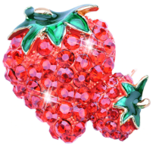 | Double Strawberry rhinestone | dbl sb | $5
 | Enamel Rhinestone Strawberry Pin | en-rh-sb | $8 | 1 3/21/2020
 | Sm red cast metal Strawberry Pin | 1-cast | $3 | 7 3/21/2020
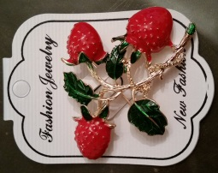 | Triple strawberry cast metal pin | 3-cast | $5 | 4 3/21/2020
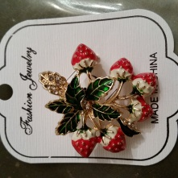 | cluster of 6 strawberries  about 1 ½ “ x 1 ½” | 6-SB | $8.50 | 2 3/21/2020
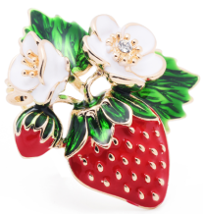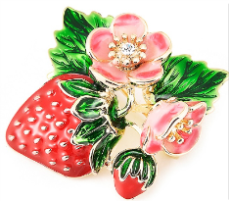 | red cast metal & enameled strawberry with flowers | SB-flowers | $6.00 | 1 w/white  3/21/2020
 | Sm blinking strawberry pin | light | 50¢
 | Large silver pin w/pearl  2 ½” diameter  clutch back | 1 | $12 | 5 3/21/2020
 | Large fan  2 ½” diameter  clutch back | fan | $12 | 5 3/21/2020
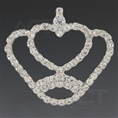 | Heart crown pin  2 3/8” wide  clutch back | 2 | $12 | 2 3/21/2020
 | Flat 3 1/8” wide  Pin back | 3 | $10 | 2 3/21/2020
 | Flat 3 3/8” wide (on card)  Pin back | 4 | $10 | 10 3/21/2020
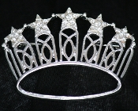 | Crystal crown pin with stars  Pin back | 006 | 7.00 | 1 3/21/2020
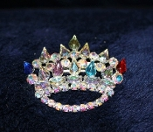 | AB & multi-color stones Crown Pin  2 ¼” wide  pin back | 5 | $10.00
 | Rhinestone & AB  2” wide pin back | 5.25AB | $6 | 3 3/30/2020
 | Rhinestone & AB  2” wide pin back | 5.5 C-AB | $6 | 3 3/20/2020
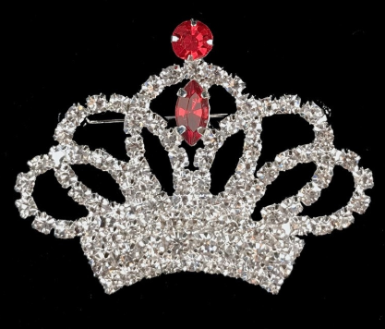 | Rhinestone & Red  2” wide pin back | 5.5 C-R | $6 | 3 3/20/2020
 | Rhinestone & Blue  2” wide pin back | 5.5 C-B | $6 | 3 3/20/2020
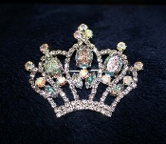 | large rhinestone & AB  pin back  2 ¾” wide | 6 | $10.00
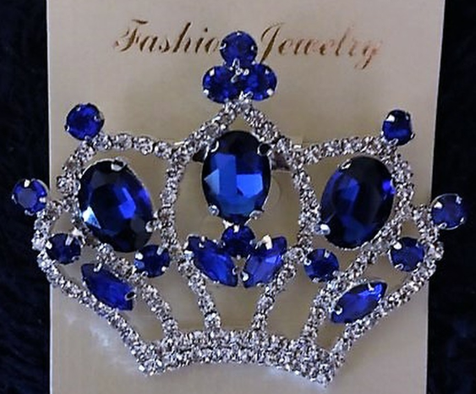 | large rhinestone & blue pin  pin back  2 ¾” wide | 6-B | $10.00 | 1
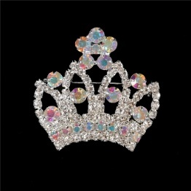 | rhinestone & AB pin  pin back  1 ½” wide | 6.5 | $6 | 3 3/20/2020
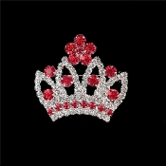 | large rhinestone & blue pin  pin back  2 ¾” wide | 6.5R | $6 | 5 3/20/2020
 | AB Crown Pin  2” wide x 1 ¼ “ tall | 7 | $6.00
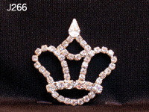 | Rhinestone crown  Pin back  1 ¾” diameter | J266 | 7.00
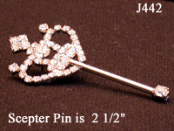 | 2 ½” scepter  Pin back | J442 | $10.00 | 4 3/21/2020
 | 3 1/8” scepter  Pin back | 8 | $11.00 | 13 3/21/2020
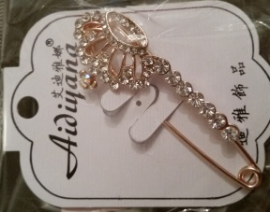 | gold tone & rhinestone crown safety pin | 9 | $8.00 | 2 3/21/2020
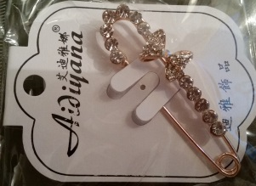 | gold tone & rhinestone Bo peep safety pin | 10 | $8.00 | 3 3/21/2020
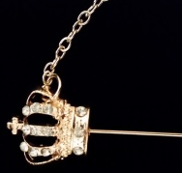 | gold tone & rhinestone crown stick pin | 11 | $5.00 | 4 3/21/2020
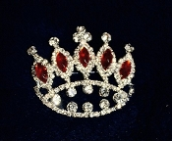 | rhinestone with red stones  2 ¼” wide  pin back | 12 | $10.00
 | green, red, blue crown pin | 13 | $4
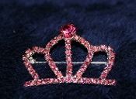 | pink rhinestone pin  1 ½” wide  pin back | 14 | $5 | 9 3/21/2020
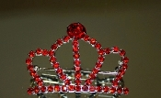 | red rhinestone pin  1 ½” wide  pin back | 15 | $5 | 1 10/30/19
 | red rhinestone pin  2” wide  pin back | 15-2 | $7 | 4 3/20/2020
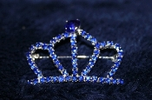 | bright blue rhinestone pin  1 ½” wide  pin back | 16 | $5
 | Small crown pin clear, round stones  1 ¼” wide x 1” tall  pin back gold tone | 17 | $5 | 5 3/21/2020
 | Small crown pin clear  1 ¼” wide x 1” tall  pin back silver tone | 18 | $5 | 16 3/21/2020
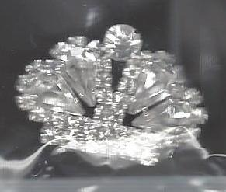 | Small crown pin, round & tear drop stones  1 ¼” wide  pin back | 9488 | $5 | 2 3/21/2020
 | Small crown pin with large center tear drop stone  1 ¼” wide  pin back | 19 | $5 | 3 3/21/2020
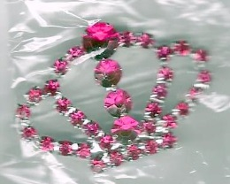 | pink rhinestone pin  1 ¾ ” wide  pin back | 20 | $6 | 1 3/21/2020
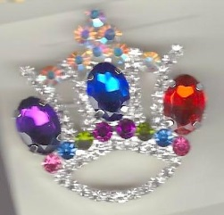 | AB & multi-color crown pin  1 ½” wide 1 ¾” tall | 21 | $12 | 13 3/21/2020
 | 2” wide x 1 ½” tall  Red stone | 22 | $5
 | 2” wide x 1 ½” tall  Clear stone | 23 | $5
 | 2” wide x 1 ½” tall  AB stone | 24 | $5
 | 2” wide x 1 ½” tall  Blue stone | 25 | $5
 | 2” wide x 1 ½” tall  Purple stone | 26 | $5.00 | 1 3/21/2020
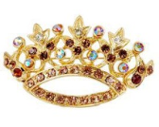 | amber-brown rhinestone pin  2 ½” wide x 1 ½” tall | 27 | $8.00 | 1 3/21/2020
 | blue rhinestone pin  2 ½” wide x 1 ½” tall | 28 | $8.00 | 2 3/21/2020
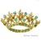 | green rhinestone pin  2 ½” wide x 1 ½” tall | 29 | $8.00 | 1 3/21/2020
 | red rhinestone pin  2 ½” wide x 1 ½” tall | 30 | $8.00 | 2 3/21/2020
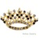 | deep purple rhinestone pin  2 ½” wide x 1 ½” tall | 31 | $8.00 | 3 3/21/2020
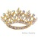 | AB rhinestone pin  2 ½” wide x 1 ½” tall | 32 | $8.00 | 1 3/21/2020
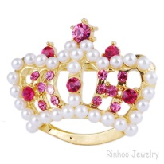 | Gold Pearl & Pink rhinestone Pin | 33 | $5 | 1 3/21/2020
 | Gold Pearl & Red rhinestone Pin | 34 | $5
 | Gold Pearl & Green rhinestone Pin | 35 | $5
 | Gold Pearl & Amber rhinestone Pin | 36 | $5 | 3 3/21/2020
 | Gold Pearl & blue rhinestone Pin | 37 | $5
 | Gold Pearl & clear rhinestone Pin | 38 | $5 | 1 3/21/2020
 | Floral Crown pin | 39 | $5.00 | 4 3/21/2020
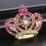 | Pink Crown Pin  2 ¼” wide x2” tall gold tone | 40 | $5
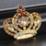 | Amber Crown Pin  2 ¼” wide x2” tall gold tone | 41-P | $5 | 1 3/21/2020
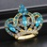 | Lt. Blue Crown Pin  2 ¼” wide x2” tall gold tone | 42-p | $5
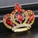 | Red Crown Pin  2 ¼” wide x2” tall gold tone | 43-p | $5
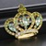 | Green Crown Pin  2 ¼” wide x2” tall gold tone | 44-p | $5
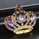 | Purple Crown Pin  2 ¼” wide x2” tall gold tone | 45-p | $5
 | silver tone crown pin with sapphire stones, cross on top | 46-p | $5.00 | 4 3/21/2020
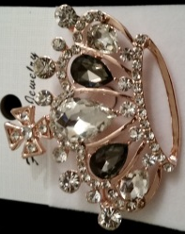 | gold tone crown pin with onyx & clear stones, cross on top | 47-p | $5.00 | 5 3/21/2020
 | Sapphire Crown Pin  2 ½ ” wide x 2“ tall gold tone | 48-p | $6.50 | 1 3/21/2020
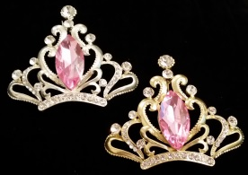 | Pink Crown Pin  2 ½ ” wide x 2“ tall silver tone | 49-p | $6.50 | 1 3/21/2020
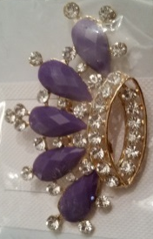s | gold tone crown pin with large deep purple stone & clear round stones | 50-p | $5.00 | 3 3/21/2020
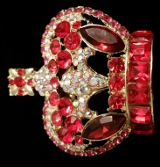 | gold tone crown pin red stones  2” wide x 2” tall | 51-p | $12.00 | 9 3/21/2020
 | Sm tac pin with clear pink & blue  ½” wide x ½ “ tall | 52-p | $1.50 | 1 3/21/2020
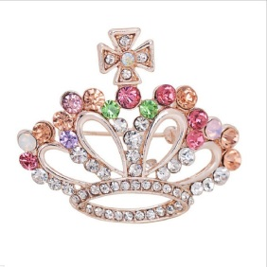 | Multi-color crown pin  1 ¾” wide x 1 ½” tall | 53-p | $5.00 | 1 3/21/2020
 | clear crown pin with cross  2 ½ “ wide x 1 ¾ “ tall | 54-p | 8.50 | 4 3/21/2020
 | AB & Pearl copper tone pin  1 ¾” wide x 1” tall | Mei | $6.00
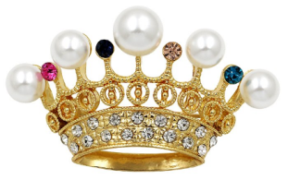 | multi color stones & pearl copper tone pin  1 ¾” wide x 1” tall | 55-p | $6.00 | 4 3/21/2020
 | AB & clear stones  1 ¼ “ wide X ¾ “ tall (in box) | 56-p | $7.50 | 4 3/21/2020
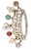 | Multi color stones & pearls  gold tone 2” wide x 1” tall | 57-p | $5.00
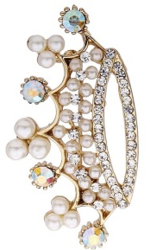 | AB stones & pearls  gold tone 2” wide x 1” tall | 58-p | $5.00
 | AB stones & pearls  silver tone 2” wide x 1” tall | 59-p | $5.00
 | Clear stones silver tone | 60-p | $5.00 | 1 3/21/2020
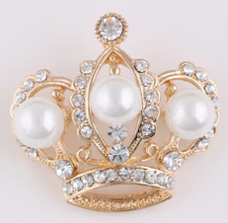 | gold tone crown pin with 3 large pearls | 61-p | $6.00 | 4 3/21/2020
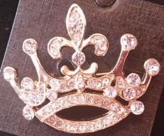 | all clear stones  silvertone 2” wide x 1” tall | 62-p | $5.00
 | gold tone crown with fleur de lei top | 63-p | $5.00
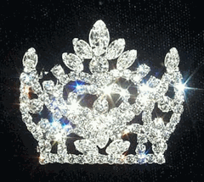 | NAVETTE Crown Pin | 64-p | $12.00 | 10 3/21/2020
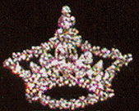 | rhinestone crown pin  pin back | j441 | $10
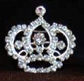 | rhinestone rounded crown pin  pin back | 65-p | $8 | 4 3/21/2020
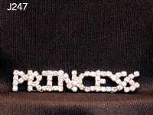 | Rhinestone “Princess”  2” long pin back | J247 | $6.00 | 2 3/21/2020
 | Rhinestone curved “Princess” with crown dangle  4” long pin back | 66-p | $13.00 | 1 3/21/2020
 | Rhinestone curved “Princess” with crown dangle  3 ¼ ” long pin back | 67-p | $12 | 3 3/21/2020
 | Rhinestone straight “Princess” with crown dangle  2 ¾ ” long pin back | 68-p | $12 | 17 3/21/2020
 | Little Miss with crown | 69-p | $12 | 10 3/21/2020
 | Curved Queen pin | 70-p | $8
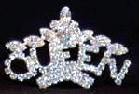 | “ Queen topped with crown”  2” long curved  Pin back | 71-p | $8 | 2 3/21/2020
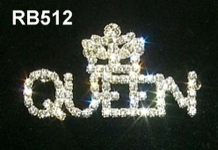 | “ Queen topped with crown”  2 3/8” long  Pin back | RB512 | 10.00
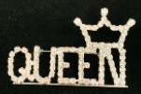 | “ Queen topped with crown”  2 ¼“ long pin back | 72-QC | $9.00 | 9 3/28/2020
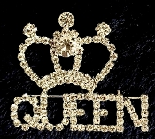 | 2 ¼” wide x 2” tall | 72-p | $12.00 | 3 3/21/2020
 | Queen with red & clear crown  2 ½ “ wide x 2” high | 73-p | $15
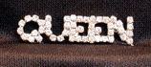 | 2 ¼” queen pin  pin back | 74-p | $8.00
 | King rhinestone pin 1 1/8” x ¼ “ | JS244 | $6 | 3 3/21/2020
 | rhinestone king pin with crown | JS349 | $10 | 3 3/21/2020
 | 2 1/8” rhinestone prince pin | 74-p | $7 | 3 3/21/2020
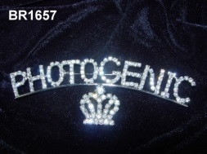 | Photogenic with dangle crown  3 ¼”  Pin back | 75-p | 8.00 | 1 3/21/2020
 | rhinestone photogenic with metal stars | 76-p | 10.00
 | director pin  silver tone | 77-p | $12 | 7 3/21/2020
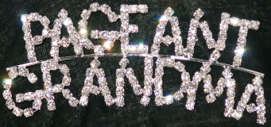 | pageant grandma pin curved  pin back  3 ¾ ” wide | 78-p | $12.00 | 3 3/21/2020
 | pageant grandma pin almost straight  pin back  3” wide | 79-p | $12 | 3 3/21/2020
 | Queen Grandmom  pin back 3 ¾ ” wide | 80-p | $12 | 33 3/21/2020
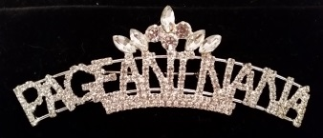 | Pageant nana rhinestone pin  3” w x 1 ¼” L | 81-p | $12 | 1 3/21/2020
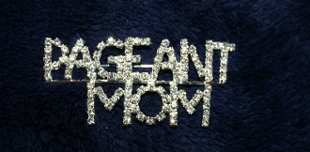x | pageant mom Large 3” wide (straight) | 82-p | $12 | 2 3/21/2020
 | pageant mom, uneven rhinestone letters | J280 | $6.00 | 4 3/21/2020
x | Script Mom with red crown | 83-p | $10 | 18 3/21/2020
 | Dad  1 ¼” L x ½” w | 84-p | $8 | 5 3/21/2020
 | US Flag Pin  2 ½ ” wide x 1 ¾ “ high | flag | $10.00
 | 2010 pin back | B2010 | 4.00  Clearance to $4 or best offer | 1 3/21/2020
 | greyhound pin | 85-p | $5.00 | 1 3/21/2020
 | Wooden pink daisy pins  pin back | 86-w | 2.00 | 6 3/21/2020
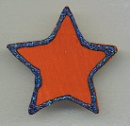 | Wooden stars  pin back | 87-w |  | 3 3/21/2020
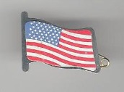 | flag pin  (sticker on metal with safety pin) | 88-p | 10¢ | 113 3/21/2020
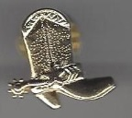 | Cowboy boot gold tone clutch pin | 89-p | $1.00  Can’t restock | 2 3/21/2020
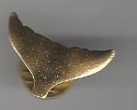 | wings gold tone clutch pin | 90-p | $1.00  Can’t restock | 1 3/21/2020
 | Wooden Snowman Pin with Christmas Tree | 91-p | $2.00  Can’t restock | 1 3/21/2020
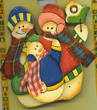 | Wooden Snowman Family pin | 92-p | $2.00  Can’t restock | 1 3/21/2020
BUTTONS | Item Description | Item Number | Selling Price
 | London Strawberry Festival (arched across top)  London, Ohio (straight across bottom) | 93-b | 3.00 | 111 3/25/2020
 | London Strawberry (arched across top)  Festival (straight across bottom | 94-b | $3.00
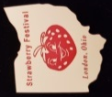 | London Strawberry on Ohio Dye Cut | 95-p | $10
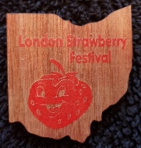 | Wooden Ohio Dye Cut with Red London Strawberry Festival Logo | WLO-R | $15 | 10 3/21/2020
 | Wooden Ohio Dye Cut with Natural London Strawberry Festival Logo | WLO-N | $15 | 8 3/21/2020
miscuts & misprints | LSF (iffy) | 96-mb | 10¢
mis-seals | LSF | 97-mb | free
 | 2007 Old Fashioned Christmas | 07OLF | 10¢
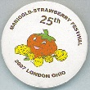 | 25th Anniversary | 2thann | 75¢ | 4 3/21/2020
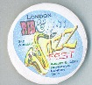 | 2010 Rib & Jazz Fest | 10 J & R | 10¢ | 3 3/21/2020
 | Bicentennial button | bic-b | 75¢ | 8 3/21/2020
Car Show Plaque Pins
Halloween Car & Motorcycle Show
November 4, 2017
Auto Show
June 21, 2018

